**­­­­­­­­­­­­­­Comparative Study: Phenylepherine Versus Ephedrine For Management Of Hypotension During Spinal Anesthesia For Ceasarean Section**

**HODA AHMED LOTFY REZKANA MD**1 **IHAB SAEED ABDEL AZIM MD**1 **Eslam Ali Shaboob MSc**1 **,**

1. **Department of anesthesia ,Benha faculty of medicine , Benha university.**

**Abstract** BACKGROUND:The purpose of this study was to compare maternal and fetal haemodynamic changes, and umbilical artery pH in subjects allocated randomly to receive phenyl epherine or ephedrine for treatment of hypotension during spinal anesthesia for elective caesarean section Two hundred patient were randomly allocated into two equal groups : Group A : receive phenylephrine (1 ml). 100µg Group B : receive ephedrine (1 ml) 6 mg

**METHODS:** Two hundred patient were randomly allocated into two equal groups : Group A : receive phenylephrine (1 ml). 100µg Group B : receive ephedrine (1 ml) 6 mg After spinal Anesthesia and hypotension all patients were placed supine with left uterine displacement standard monitors like non-invasive BP (blood pressure), ECG and pulse oximeter were applied. Base line heart rate, systolic BP and diastolic BP were calculated as mean of three successive readings measured one minute apart. An 18 gauge I/V line taken and all patients were preloaded with 10 ml/kg lactated Ringer’s solution over 10 min then infusion rate was reduced to keep vein open.Lumbar puncture done in sitting position at L 3-4 interspace with 25 gauges Quincke needle. In every patient after confirming the free flow of CSF, 2ml (10mg) of 0.5% hyperbaric bupivacaine injected intrathecally. Patients were then immediately placed supine with 15 degree left lateral tilt position using wedge under right hip. All patients were given supplemental oxygen at 5 lit.min-1 via facemask. After SA heart rate, systolic and diastolic blood pressures were recorded at two minute interval until end of the procedure.

**RESULTS:** Two hundred and ninety eight parturient scheduled for cesarean delivery, fulfilling the inclusion and exclusion criteria were enrolled in this study. Hypotension occurred in 67.11 % parturient. Ninety-eight parturient who did not develop hypotension were excluded from the study. So total of two hundred parturient were included in the study and divided into two groups of 100 patients in each group Ninety two percent patients of Group A required 100 µg of phenylephrine while seventy eight percent patients of Group B required 6 mg ephedrine to treat hypotension, which was statistically significant (p=0.0009). Eight percent patients in the Group A (phenylephrine) and twenty two percent patients in Group B (ephedrine) needed second dose of vasopressor to maintain systolic blood pressure

**CONCLUSION:** Intravenous bolus doses of phenylephrine 100 µg and ephedrine 6 mg were both effective in treating hypotension after SA for elective cesarean section. Phenylephrine was comparatively more effective because less bolus doses were required to treat hypotension than ephedrine. Mean Apgar scores of the neonates at 1 and 5 min were comparable between the two groups.

**Keywords**: PHENYLEPHRINE EPHEDRINE HYPOTENSION SPINAL ANAESTHESIA.

**INTRODUCTION :**

Hypotension is perhaps the most common complication of neuraxial anesthesia in obstetric patients**[1]**. It has been estimated to occur in approximately 30% - 70% of cases**[2]**.

Maternal hypotension produces unpleasant symptoms such as nausea, vomiting, and lightheadedness. More importantly, when severe and sustained, hypotension it can impair uterine and intervillous blood flow and ultimately result in fetal acidosis and neonatal depression **[1-5]**. Prevention measures include fluid preload, left lateral tilt, and use of vasopressors **[6]**.

Traditionally, ephedrine “which has a strong *β*-adrenergic and a weaker *α*-adrenergic effects” has been recommended in this situation, but its position has been challenged because of potential complication like supra- ventricular tachycardia, tachyphylaxis, and most importantly fetal acidosis**[4]**. Phenylephrine, an *α*-adrenergic agonist, can be used for prevention and treatment of maternal hypotension. Moreover, phenylephrine reduces the incidence of nausea and vomiting as well as fetal acidosis, but it may cause maternal bradycardia**[6]**.

Present study compared ephedrine with phenylephrine in treatment (not prevention) of maternal hypotension induced spinal anesthesia regarding the maternal cardiac response to hypotension in terms maternal hemodynamic and fetal/neonatal status.

**PATIENTS AND METHODS:**

* **Ethics Committee :**
* The study protocol was approved by the institutional ethical committee of Benha University Hospital.
* Informed patient written consent was obtained before envolvement in the study.
* **Type of study :**
* Randomized double blind study.
* **Methods of randomization :**
* Patients were randomized into two equal groups.
* **Inclusion criteria :**

1. Age: 18 to 35 years old.
2. Height: 150 - 170 cm.
3. Weight: 65 – 90 kg.
4. Elective and uncomplicated cesarean delivery.
5. Full term pregnancy.
6. ASA I and II.

* **Groups allocation :**
* Two hundred patient were randomly allocated into two equal groups :

1. **Group A :** receive phenylephrine (1 ml). 100µg
2. **Group B :** receive ephedrine (1 ml) 6 mg

* After spinal Anesthesia and hypotension
* **Exclusion criteria :**
* Pre-existing pregnancy included hypertension.
* Pre-eclampsia.
* Diabetes mellitus.
* Morbid obesity (Body mass index **≥** 45 kg/m²).
* Height  **<** 150 cm.
* Laboring women.
* Urgent or emergency cesarean section.
* Known cardiovascular or cerebrovascular diseases.
* Fetal abnormalities.
* Sensitivity to drugs.
* Failed spinal anesthesia.



* Contraindication to [Spinal Anesthesia](http://www.nysora.com/techniques/neuraxial-and-perineuraxial-techniques/landmark-based/3423-spinal-anesthesia.html)
* **Preoperative visit :**
* One day before surgery all patients were interviewed to explain the procedure of Spinal Anesthesia and the follow up of baby.
* Also routine investigations in the form of twelve leads electro cardiography (ECG), complete blood count (CBC), coagulation profile (bleeding time, prothrombin time, international normalization ratio and partial thromboplastine), liver functions, kidney functions were fulfilled.
* **Preparation of the patients :**
* All patients were fasted for 6-8 hours prior to anesthesia and received aspiration prophylaxis preoperatively as intravenous ranitidine 50 mg, metoclopramide 8 mg .
* **Technique study in the operating room**
* all patients were placed supine with left uterine displacement
* standard monitors like non-invasive BP (blood pressure), ECG and pulse oximeter were applied.
* Base line heart rate, systolic BP and diastolic BP were calculated as mean of three successive readings measured one minute apart.
* An 18 gauge I/V line taken and all patients were preloaded with 10 ml/kg lactated Ringer’s solution over 10 min then infusion rate was reduced to keep vein open.
* Lumbar puncture done in sitting position at L 3-4 interspace with 25 gauges Quincke needle. In every patient after confirming the free flow of CSF, 2ml (10mg) of 0.5% hyperbaric bupivacaine injected intrathecally.
* Patients were then immediately placed supine with 15 degree left lateral tilt position using wedge under right hip.
* All patients were given supplemental oxygen at 5 lit.min-1 via facemask.
* After SA heart rate, systolic and diastolic blood pressures were recorded at two minute interval until end of the procedure.
* Sensory block to T5 level was considered appropriate for surgery.
* After confirming the level of block to T5 by pinprick method, surgeons were asked to proceed for the surgery.
* Hypotension was defined as systolic BP less than 90 mm Hg or decreases in systolic BP more than 20% of base line whichever is lower.
* Patients were randomly assigned to receive one of two vasopressor drugs whenever hypotension occurs.
* The Group-A patients received 1 ml (100µg) intravenous bolus of phenylephrine while Group-B patients received 1ml (6mg) intravenous bolus of ephedrine.
* In cases, where hypotension did not improve additional boluses of same vasopressor was given to keep systolic BP ≥90mmHg. All patients were randomized by computer generated number allocation using PASS software.
* The study drugs were prepared in similar 5 ml syringes and labeled A and B by primary anesthesiologist neither involved in patient management nor in the data collection. In case of bradycardia (heart rate < 50 beats/min), atropine 0.6 mg was given intravenously.
* Just after delivery of the baby, oxytocin 20 units slow intravenous infusion.
* **Parameters used in the study ;**

1. Maternal out come measures :
2. Hypotension (systolic blood pressure **<** 20% of baseline)measured at 2 minute interval.
3. Bradycardia measured at 2 minute interval.
4. Number of vasopressor doses, total dose of vasopressor required and use of atropine were recorded
5. Neonatal out come measures :
6. The Apgar scores of all neonates were noted at 1 min and 5 min after the delivery by a pediatrician, blinded to the group allocation.
7. Umbilical cord blood gases and Fetal acidosis.

* **Data management and statistical analysis :**
* Analysis of data was done by using SPSS version 16.
* Quantitative data was presented as mean **±** standard deviation.
* Qualitative data was presented as numbers and percentages.
* Quantitative data was analysed by using unpaired student T-Test.
* Quantitative data in the same group was analysed by using repeated measure ANOVA test.
* Quantitative data was analysed by using Chi-square and Z test.
* P-value **<** 0.05 was considered statistically significant.
* P-value **<** 0.01 was considered statistically highly significant.
* A sample size of at least ten patients was needed to have the power of least 80%, the two sided error of 5% level and on the basis that from our previous studies we would expect.

**RESULTS:**

Two hundred and ninety eight parturient scheduled for cesarean delivery, fulfilling the inclusion and exclusion criteria were enrolled in this study. Hypotension occurred in 67.11 % parturient. Ninety-eight parturient who did not develop hypotension were excluded from the study. So total of two hundred parturient were included in the study and divided into two groups of 100 patients in each group.

Demographic, clinical characteristics and indication of cesarean delivery are presented in Table 2. The two groups were comparable with respect to age, weight, ASA physical status and indication of cesarean delivery but a statistically significant difference existed in height of parturient (p= 0.033) between the groups. Sensory level of block was achieved up to T5 or above in all patients that were comparable in both groups.

**Table 2:** Demographics, clinical characteristics of parturient and indications of cesarean delivery

|  |  |  |  |
| --- | --- | --- | --- |
| **Variables** | **Group – A**  **n =100** | **Group – B**  **n =100** | **P-values** |
| Age (years) | 26.88± 3.23 | 26.92± 4.45 | 0.94 |
| Weight (kg) | 67.10± 5.32 | 72.12± 4.16 | 0.146 |
| Height (cm) | 160.32± 3.97 | 159.38± 1.88 | 0.033 |
| ASA physical status |  |  |  |
| I | 61% | 69% | 0.23 |
| II | 39% | 31% |
| Indication of cesarean delivery |  |  |  |
| FTP CPD | 28% | 26% | 0.75 |
| Previous cesarean | 50% | 44% | 0.39 |

**Maternal outcome**

Ninety two percent patients of Group A required 100 µg of phenylephrine while seventy eight percent patients of Group B required 6 mg ephedrine to treat hypotension, which was statistically significant (p=0.0009). Eight percent patients in the Group A (phenylephrine) and twenty two percent patients in Group B (ephedrine) needed second dose of vasopressor to maintain systolic blood pressure

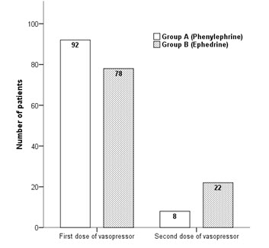  
**Figure 1:** Comparison of intravenous bolus doses of vasopressors required to treat hypotension

There was statistically significant difference exist in mean systolic blood pressure between group A and group B at three to seven and twelve minute time intervals, as presented in ***Figure 2.***

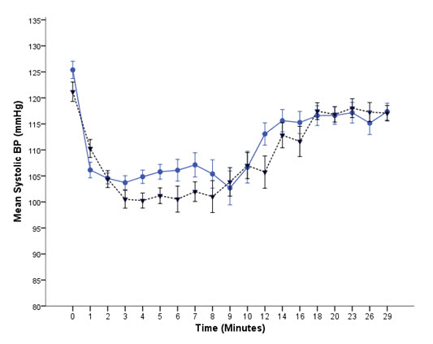

**Figure 2:** Comparison of mean systolic blood pressure between Group A and Group B with respect to time

**Maternal heart rate changes**

**Table (3):** Descriptive statistics 0f maternal heart rate in group (A)

|  |  |  |  |  |  |
| --- | --- | --- | --- | --- | --- |
|  | **Minimum** | **Maximum** | **Mean** | **Std.Deviati0n** | **p-Value** |
| Base  2 mins  4 mins  6 mins  8 mins  10 mins  12 mins  14 mins  16 mins  18 mins  20 mins | 70.00  80.00  89.00  89.00  93.00  93.00  87.00  82.00  77.00  89.00  88.00 | 106.00  122.00  121.00  120.00  118.00  118.00  115.00  111.00  108.00  100.00  100.00 | 90.1333  95.6000  101.7333  106.7333  106.2000  104.3333  101.0000  98.2667  96.3333  94.9333  93.3333 | 9.47830  10.93357  9.30028  8.62278  8.35122  8.59956  7.83764  7.81452  8.50770  8.03472  3.33095 | 0.001(*) |

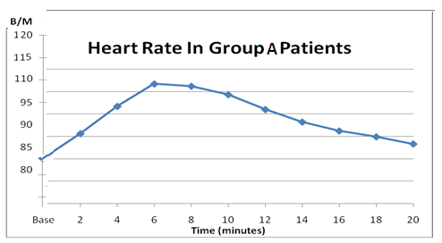(*) significant Value

**Figure (3):** Maternal heart rate changes in gr0up (**A**)

ANoVA test showed a statistical significant changes in maternal heart rate within group (**A**) (p value=0.001).

**Table (4):**Descriptive statistics 0f maternal heart rate in gr0up (**B**).

|  |  |  |  |  |  |  |
| --- | --- | --- | --- | --- | --- | --- |
|  | **Minimum** | **Maximum** | **Mean** | **Std.Deviation** | | **P-Value** |
| Base  2 mins  4 mins  6 mins  8 mins  10 mins  12 mins  14 mins  16 mins  18 mins  20 min | 77.00  77.00  79.00  76.00  75.00  80.00  82.00  83.00  85.00  81.00  82.00 | 110.00  107.00  100.00  102.00  103.00  106.00  105.00  108.00  105.00  101.00  99.00 | 90.1333  95.6000  101.7333  106.7333  106.2000  104.3333  101.0000  98.2667  96.3333  94.9333  93.3333 | | 8.9697  8.43010  6.09293  7.49730  7.85281  7.50682  6.48588  7.37951  5.67534  5.59166  5.3966 | 0.006 |

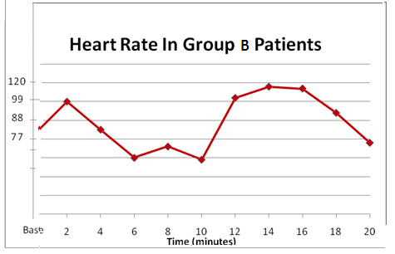

**Figure (4):** Maternal heart rate changes in group (**B**).

AN0VA test showed a statistical significant changes in maternal heart rate within group (B) (p value=0.006).

***By d0ing AN0VA test*** to c0mpare maternal heart rate differences between all gr0ups ,we f0und that there were statistical significant difference in maternal heart rate between two gr0ups till reaching 12 mins readings (p value = 0.01), then there were statistical insignificant differences in maternal heart rate between all groups till reaching 20 mins reading (p value = 0.09).

**Maternal syst0lic bl00d pressure (SBP):**

**Table(5):** Descriptive statistics 0f SBP in gr0up (A):

|  |  |  |  |  |  |
| --- | --- | --- | --- | --- | --- |
|  | **Minimum** | **Maximum** | **Mean** | **Std.Deviation** | **P-Value** |
| **base**  **2 mins**  **4 mins**  **6 mins**  **8 mins**  **10 mins**  **12 mins**  **14 mins**  **16 mins**  **18 mins**  **20 mins** | 110.00  99.00  77.00  73.00  92.00  104.00  102.00  110.00  112.00  110.00  110.00 | 135.00  132.00  123.00  130.00  124.00  128.00  126.00  130.00  128.00  124.00  120.00 | 122.5  114.8000  100.2667  103.2667  108.0667  113.4000  116.0667  119.6000  120.9333  116.6000  114.4667 | 3.37454  9.62421  10.25352  12.93647  9.80136  7.13943  6.20445  5.91366  4.30061  4.10226  3.60231 | 0.001 |

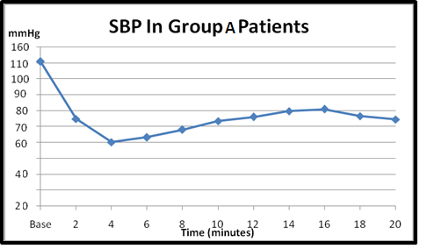

**Figure (5):** SBP changes in gr0up (A)

AN0VA test sh0wed a statistical significant changes in maternal syst0lic bl00d pressure within gr0up **(A)** (p value = 0.001).

**Table (6):** Descriptive statistics 0f SBP in gr0up(B)

|  |  |  |  |  |  |
| --- | --- | --- | --- | --- | --- |
|  | **Minimum** | **Maximum** | **Mean** | **Std.Deviati0n** | **P-Value** |
| **Base**  **2 mins**  **4 mins**  **6 mins**  **8 mins**  **10 mins**  **12 mins**  **14 mins**  **16 mins**  **18 mins**  **20 mins** | 100.00  85.00  80.00  90.00  93.00  95.00  100.00  103.00  102.00  105.00  102.00 | 130.00  135.00  110.00  112.00  115.00  112.00  120.00  125.00  120.00  115.00  119.00 | 115.0000  114.7333  98.6000  100.8667  103.8667  105.3333  109.5333  111.8667  109.7333  108.7333  110.2667 | 4.969632  15.21497  7.70714  6.87508  6.83339  5.80230  4.61158  4.62704  5.20256  3.86313  4.99238 | 0.001 |

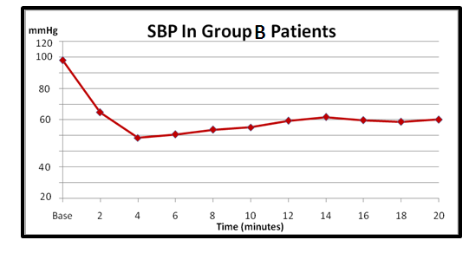

**Figure (6):** SBP changes in gr0up (B)

AN0VA test sh0wed a statistical significant changes in maternal syst0lic bl00d pressure within gr0up (B) (p value=0.001).

***By d0ing AN0VA test*** t0 c0mpare maternal syst0lic bl00d pressure differences between all gr0ups ,we f0und that there were n0 statistical significant difference in SBP between two gr0ups till reaching 8 mins readings (p value was m0re than 0.05), then there were statistical significant differences in SBP between two gr0ups till reaching 20 mins reading ( p value= 0.001).

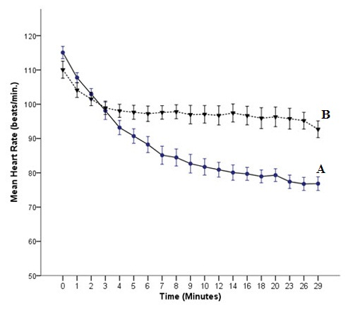

**Figure 7:** Comparison of mean heart rate between Group A and Group B with respect to time

Complications like bradycardia, nausea and vomiting were also recorded. Incidence of bradycardia (heart rate < 50 beats/mints) was significantly higher in Group A (15%) as compared to Group B (6%) (p=0.038). Comparison of mean heart rate between Group A and Group B with respect to time is presented in Figure 7. Incidence of nausea and vomiting were relatively higher in Group B as compared to Group A but were not statistically significant (p=0.56 and p=0.72 respectively~~)~~ No parturient developed oxygen desaturation, SPO2 < 95%. Mean Birth Weight (in kilogram) of neonates of Group A was 2.67± 0.19 and Group B was 2.64 ± 0.18 which were comparable.

**Neonatal outcome**

Mean Apgar scores were comparable between the groups, at 1 minute (p=0.76), and at 5 min (p= 0.09)***(Figure 8).***

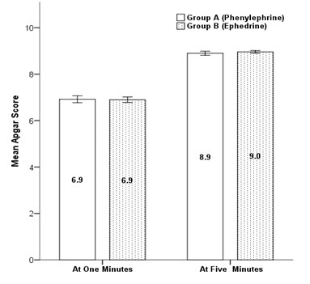

**Figure 8:** Comparison of mean Apgar score between groups at 1 and 5 min

Umbilical arterial blood gas analyses are summarized in [***Table 7***](https://www.ncbi.nlm.nih.gov/pmc/articles/PMC4884253/table/T3/)***.*** Based on the one-way ANOVA test, there was a significant difference in PH between groups. Umbilical arterial PH was significantly lower in ephedrine group (P = 0.0005), but none of the neonates had the true fetal acidosis ***(***[***Figure 9***](https://www.ncbi.nlm.nih.gov/pmc/articles/PMC4884253/figure/F2/)***).*** There were no differences between groups regarding HCO3 concentrations and base excess values (Be) in the umbilical arterial blood gas analyses.

**Table 7:** Neonatal Data

|  |  |  |  |  |
| --- | --- | --- | --- | --- |
|  | **Total** | **Group B** | **Group A** | **P value** |
| **Umbilical arterial PH** | 7.32 ± 0.04 | 7.31 ± 0.04 | 7.33 ± 0.04 | 0.0005 |
| **HCO3 (mmHg)** | 22.55 ± 2.10 | 22.57 ± 1.87 | 22.52 ± 2.32 | 0.86 |
| **Base excess (mmol.l-1)** | - 3.39 ± 1.90 | - 3.48 ± 2.02 | - 3.30 ± 1.78 | 0.50 |

An external file that holds a picture, illustration, etc.
Object name is OAMJMS-4-54-g002.jpg

**Figure 9 :**Comparison of umbilical arterial blood pH value between the study groups.

The pediatrician assessed the c0nditi0n 0f ne0nates at delivery time using Apgar sc0re at 1 and 5 mins.

**Table (8):** Descriptive statistics 0f APGAR sc0res.

|  |  |  |  |  |  |
| --- | --- | --- | --- | --- | --- |
| **Gr0up** | **Apgar sc0re** | **Minimum** | **Maximum** | **P value**  **at 1 min** | **p value**  **at 5 mins** |
| A | at 1 min.  at 5 min. | 7.00  9.00 | 8.00  10.00 | 0.856 | 0.561 |
| B | at 1 min.  at 5 min. | 7.00  9.00 | 8.00  10.00 |

**DISCUSSION**

Maternal hypotension is the most common and important physiological response to SA due to preganglionic sympathetic block with important maternal and fetal consequences. In literature overall incidence of hypotension during SA for cesarean section is 80% but in this study it was 67%. Traditionally, non-pharmacological interventions such as leg elevation, compressive leg devices, left uterine displacement and intravenous fluid preloading have been used but vasopressors are often required.**7**

Ephedrine and phenylephrine have been used for the treatment of intra-operative hypotension in many studies. Ephedrine is effective in the treatment of spinal induced hypotension during cesarean sections, but it can cause fetal acidosis.**8** Updated meta-analysis by ***Lin FQ et al.*** showed comparable results between prophylactic ephedrine and phenylephrine to manage spinal-induced hypotension but parturient treated with phenylephrine had neonates with higher umbilical pH value than those treated with ephedrine.**9**

Ephedrine is a mixed α and β agonist and causes increase in cardiac output and heart rate. Ephedrine crosses placenta and causes increase in oxygen consumption and increase in glucose and lactic acid concentrations. Phenylephrine is a pure α1 adrenergic agonist, which increases systemic vascular resistance and causes reflex bradycardia but it maintain cardiac output in healthy parturient.**10**

***Ngankee WD et al.*** showed that overall phenylephrine has beneficial effects on fetal oxygen supply and demand balance. It crosses the placenta to a lesser extent than ephedrine.**11** ***Dyer et al***. showed that maternal cardiac output is decreased with bolus phenylephrine in comparison to ephedrine but phenylephrine was effective in obtunding the hemodynamic changes in response to oxytocin.**12** ***Doherty et al.*** compared phenylephrine infusion with the bolus regimens during cesarean section under SA and found that both regimens maintained maternal arterial blood pressures closer to baseline but the infusion regimen required a higher total dose.**13**

In this study intravenous bolus doses of phenylephrine and ephedrine were used and both were effective in treating hypotension after SA, however, less bolus doses of phenylephrine were required. ***Gunda et al.*** compared the effectiveness and the side effects of ephedrine and phenylephrine administered for treating hypotension during elective cesarean section under SA and found that both are effective in treating hypotension. They suggested that phenylephrine may be more appropriate vasopressor when considering maternal wellbeing.**14**

Meta-analysis done by ***Veeser et al.*** demonstrated a decreased risk of fetal acidosis with phenylephrine.**15 *Prakash et al.***showed that both phenylephrine 100 µg and ephedrine 6 mg were comparable in the management of hypotension during SA for elective cesarean section. Neonates in the phenylephrine group had significantly higher umbilical arterial pH and base excess values than the ephedrine group.**16**

The findings in the present study are in accordance with other studies **[**[**17**](https://www.ncbi.nlm.nih.gov/pmc/articles/PMC4884253/#ref21)**,** [**18**](https://www.ncbi.nlm.nih.gov/pmc/articles/PMC4884253/#ref22)**]** women given phenylephrine had neonates with higher umbilical arterial pH values than those given ephedrine, although there is no risk for true fetal acidosis in none of groups.

The reason for the difference in umbilical arterial pH values is that ephedrine crosses the placenta; **[**[**19**](https://www.ncbi.nlm.nih.gov/pmc/articles/PMC4884253/#ref17)**,20,** [**21**](https://www.ncbi.nlm.nih.gov/pmc/articles/PMC4884253/#ref22)**]** therefore, it is possible that ephedrine may have a direct effect on the fetus that contributes to acidosis **22.** In spite of this, fetal clinical adverse effects caused by reduced fetal pH have not been demonstrated **23**.

***Adigun TA et al.*** showed that phenylephrine is safe and comparable to ephedrine.**24*****Cooper et al.*** showed that the umbilical artery pH was similar whether ephedrine or phenylephrine was used to maintain the maternal arterial pressure during intra-thecal anesthesia in high risk cases due to fetal compromise.**25**

***Nazir et al.*** showed that phenylephrine and ephedrine are equally effective in treating hypotension during SA for elective cesarean section. Neonatal outcome and Apgar score were comparable in both the groups.**95** In this study mean Apgar scores of the neonates at 1 minute (p = 0.856) and at 5 min (p = 0.561) were comparable between phenylephrine and ephedrine groups. ***Ashraf S. Habib*** in his review showed a lower incidence of intraoperative nausea and vomiting and higher umbilical artery pH and base excess compared with ephedrine.**96**

Apgar score is the most commonly applied and easily interpretable clinical method of neonatal wellbeing and in literature. A recent meta-analysis of vasopressor choice during regional anesthesia in obstetric showed phenylephrine and ephedrine are comparable in terms of neonatal Apgar score at one and five minutes after delivery.**97**

This study has a number of limitations for instance, only uncomplicated and elective cesarean deliveries were included in the study but in complicated and emergency cases response of vasopressors may be different.

**References**

1. ***Chestnut DH.*** Chestnut’s obstetric anesthesia principles and practice. 4th Editon, Mosby, Philadelphia, 2009.
2. ***Chestunt , D.H, Wong C.A, TsenL.C, Negan Kee, W.D , Beiliny & Mhyre, J.M. 2014,*** Chestunt obstetric Anesthesia Principles, pheladelphia, PA: Elsevier Sounders.
3. ***Rasanen J, Alahuhtat S, Kangas-Saarelat T, Jouppilat R and Jouppila P.*** The effects of ephedrine on uterine and fetal blood flow and on fetal myocardial function during spinal anaesthesia for caesarean section. International Journal of Obstetric Anesthesia, 1991; **1**, 3-8. doi:10.1016/0959-289X(91)90022-I.
4. ***Loughrey JPR, Yao N, Datta S, Segal S, Pian-Smith M and Tsen LC.***  Hemodynamic effects of spinal anesthesia and simultaneous intravenous bolus of combined phenylephrine and ephedrine versus ephedrine for cesarean delivery. *International Journal of Obstetric An- esthesia*, 2005;**14**, 43-47.
5. ***Miller RD.*** Miller's anesthesia. 7th Edition, Chur- chill Livingstone, Philadelphia., 2010.
6. ***Adigun TA, Amanor-Boadu SD and Soyannwo OA.*** Comparison of intravenous ephedrine with phenylephrine for the maintenance of arterial blood pressure during elective caesarean section under spinal anaesthesia. African Journal of Medicine & Medical Sciences, 2010; **39**, 13-20.
7. ***Erler I, Gogarten W.*** Prevention and treatment of hypotension during caesarean delivery.  Anasthesiol Intensivemed Notfallmed Schmerzther 2007;42:208-13.
8. ***Lin FQ, Qiu MT, Ding XX, Fu SK, Li Q.*** Ephedrine versus Phenylephrine for the Management of Hypotension during Spinal Anesthesia for Cesarean Section: An Updated Meta-Analysis. CNS Neurosci Ther 2012;18:591–597.
9. ***Meahan FP, Burke G, Rehose Jt:*** Update on delivery following cesarean section : review 2005-2007 international J. of Gynacology & Obstetric 2008, 30 : 205-12.
10. ***Lee A, NganKee WD, Gin T.*** A dose-response meta-analysis of prophylactic intravenous ephedrine for the prevention of hypotension during spinal anesthesia for elective cesarean delivery. Anesth Analg, 2004;98:483-490.
11. ***NganKee WD, Khaw KS, Ng FF.*** Prevention of hypotension during spinal anesthesia for cesarean delivery: an effective technique using combination phenylephrine infusion and crystalloid cohydration. Anesthesiology, 2005;103:744-750.
12. [***Dyer RA***](http://www.ncbi.nlm.nih.gov/pubmed?term=Dyer%20RA%5BAuthor%5D&cauthor=true&cauthor_uid=19741494)***,***[***Reed AR***](http://www.ncbi.nlm.nih.gov/pubmed?term=Reed%20AR%5BAuthor%5D&cauthor=true&cauthor_uid=19741494)***,***[***Van Dyk D***](http://www.ncbi.nlm.nih.gov/pubmed?term=van%20Dyk%20D%5BAuthor%5D&cauthor=true&cauthor_uid=19741494)***,***[***Arcache MJ***](http://www.ncbi.nlm.nih.gov/pubmed?term=Arcache%20MJ%5BAuthor%5D&cauthor=true&cauthor_uid=19741494)***,***[***Hodges O***](http://www.ncbi.nlm.nih.gov/pubmed?term=Hodges%20O%5BAuthor%5D&cauthor=true&cauthor_uid=19741494)***,***[***Lombard CJ***](http://www.ncbi.nlm.nih.gov/pubmed?term=Lombard%20CJ%5BAuthor%5D&cauthor=true&cauthor_uid=19741494)***, et al***. Hemodynamic effects of ephedrine, phenylephrine, and the coadministration of phenylephrine with oxytocin during spinal anesthesia for elective cesarean delivery. Anaesthesiology 2009;111:753-765.
13. ***Doherety A, Ohashi Y, Downey K, Carvalho JCA.*** Phenylephrine Infusion Versus Bolus Regimens During Cesarean Delivery Under Spinal Anesthesia: A Double-Blind Randomized Clinical Trial to Assess Hemodynamic Changes. Anesth Analg 2012;115:1343–1350.
14. ***Gunda CP, Malinowski J, Tegginmath A, Suryanarayana VG, Chandra SB.*** Vasopressor choice for hypotension in elective Cesarean section: ephedrine or phenylephrine? Arch Med Sci 2010;6:257-263.
15. ***Veeser M, Hofmann T, Roth R, Klöhr S, Rossaint R, Heesen M.*** Vasopressors for the management of hypotension afterspinal anesthesia for elective caesarean section. Systematicreview and cumulative meta-analysis. Acta Anaesthesiol Scand 2012;56:810–6.
16. ***Prakash S, Pramanik V, Chellani H, Salhan S, Gogia AR.*** Maternal and neonatal effects of bolus administration of ephedrine and phenylephrine during spinal anaesthesia for caesarean delivery: A randomized study. Int J Obstet Anesth 2010;19:24–30.
17. ***Cooper DW.*** Caesarean delivery vasopressor management. Curr Opin Anaesthesiol 2012;25:300–308.
18. ***La Porta RF, Arthur GR, Datta S.*** Phenylephrine in treating maternal hypotension due to spinal anaesthesia for caesarean delivery:effects on neonatal catecholamine concentrations, acid base status and Apgar scores. Acta Anaesthesiol Scand. 2011;39:901–905.
19. ***Allen TK, George RB, White WD, Muir HA, Habib AS.*** A double-blind, placebo-controlled trial of four fixed rate infusion regimens of phenylephrine for hemodynamic support during spinal anesthesia for cesarean delivery. Anesth Analg. 2010;111:1221–1229. PMid:20495139.
20. ***Ngan Kee WD, Khaw KS, Tan PE, Ng FF, Karmakar MK.*** Placental transfer and fetal metabolic effects of phenylephrine and ephedrine during spinal anesthesia for cesarean delivery. Anesthesiology***.*** 2009;111:506–512. PMid:19672175.
21. ***Mueller MD, Brühwiler H, Schüpfer GK, Lüscher KP.*** Higher rate of fetal acidemia after regional anesthesia for elective cesarean delivery. Obstet Gynecol. 1997;90:131–134.
22. [***Ngan Kee WD***](http://www.ncbi.nlm.nih.gov/pubmed?term=Ngan%20Kee%20WD%5BAuthor%5D&cauthor=true&cauthor_uid=19672175)***,***[***Khaw KS***](http://www.ncbi.nlm.nih.gov/pubmed?term=Khaw%20KS%5BAuthor%5D&cauthor=true&cauthor_uid=19672175)***,***[***Tan PE***](http://www.ncbi.nlm.nih.gov/pubmed?term=Tan%20PE%5BAuthor%5D&cauthor=true&cauthor_uid=19672175)***,***[***Ng FF***](http://www.ncbi.nlm.nih.gov/pubmed?term=Ng%20FF%5BAuthor%5D&cauthor=true&cauthor_uid=19672175)***,***[***Karmakar MK***](http://www.ncbi.nlm.nih.gov/pubmed?term=Karmakar%20MK%5BAuthor%5D&cauthor=true&cauthor_uid=19672175)***.*** Placental Transfer and Fetal Metabolic Effects of Phenylephrine and Ephedrine during Spinal Anesthesia for Cesarean Delivery. Anesthesiology 2009;111:506–12.
23. ***Adigun TA, Amanor-Boadu SD, Soyannwo SD***. Comparison of intravenous ephedrine with phenylephrine for the maintenance of arterial blood pressure during elective caesarean section under spinal anaesthesia. Afr J Med MedSci 2010;39:13-20.
24. ***Cooper DW, Sharma S, Orakkan P.*** Retrospective study of association between choice of vasopressor given during spinal anaesthesia for high-risk caesarean delivery and fetal pH. Int J Obstet Anesth 2010;19:44-49.
25. ***Nazir I, Bhat MA, Qazi S, Buchh VN, Gurcoo SA.*** Comparison between phenylephrine and ephedrine in preventing hypotension during spinal anesthesia for cesarian section. J Obs Anesth & Critical Care 2012;2:92-97.
26. ***Habib AS.*** A review of the impact of phenylephrine administration on maternal hemodynamics and maternal and neonatal outcomes in women undergoing cesarean delivery under spinal anesthesia. Anesth Analg 2012;114:377-390.
27. ***Biddle C.*** To press or not to press, and if so, with what? A single question-focused meta-analysis of vasopressor choice during regional anesthesia in obstetrics. [AANA J.](http://www.ncbi.nlm.nih.gov/pubmed/24133847) 2013;81:261-264.